CAR RENTAL REQUEST
AUTOMATION IN SERVICENOW
USING SERVICE CATALOG AND WORKFLOWS
Project Documentation

Platform: ServiceNow • Service Catalog • Flow Designer

Prepared by
Vamsi Bhavirisetti

Individual Project

Document Information
Item | Details
Project title | Car Rental Request Automation in ServiceNow Using Service Catalog and Workflows
Platform | ServiceNow Personal Developer Instance (PDI)
Application approach | ServiceNow-native configuration; no separate React/Node.js/MongoDB application
Developer | Vamsi Bhavirisetti
Project type | Individual project
Primary components | Service Catalog, catalog variables, Flow Designer, approvals, catalog tasks, Business Rule, incident creation, email notification, Update Set

Contents
- 1. Introduction
- 2. Problem Statement and Objectives
- 3. Project Overview and Functional Scope
- 4. ServiceNow Architecture and Design
- 5. Implementation Details
- 6. Request Lifecycle and Workflow Logic
- 7. Data Model and Field Mapping
- 8. Setup and Reproduction Guide
- 9. Testing and Troubleshooting
- 10. Screenshots and Evidence
- 11. Benefits and Client Value
- 12. Limitations and Known Considerations
- 13. Future Enhancements
- 14. Conclusion

1. Introduction
The Car Rental Request Automation project is a ServiceNow-based workflow solution designed to make the submission, approval, fulfillment and communication of car rental requests more consistent. It provides a structured Car Rental Request item in the Service Catalog and uses Flow Designer to request approval, create an assignment task for the Transport Team, retrieve the submitted catalog variables and send an approval email to the requester. A Business Rule additionally creates an incident when a requested item is closed because a car is unavailable.
The project is implemented inside ServiceNow. It does not use a separate React frontend, Node.js/Express backend or MongoDB database. The user-facing request form is the ServiceNow Service Catalog interface; data is stored in standard ServiceNow tables; and process automation is configured with Flow Designer, a Business Rule and related platform configuration.

1.1 Purpose of this document
This document explains the operational problem, the solution implemented on ServiceNow, the configuration components, the request lifecycle, the supporting screenshots, how the solution can be recreated in a Personal Developer Instance, and the value it can provide to an organization that manages business car rentals.

2. Problem Statement and Objectives

2.1 Existing problem
In a manual car rental process, employees request vehicles through email, phone calls or spreadsheets. Requests can miss important details such as pickup and drop locations, duration or car type. Managers and the transport team spend time clarifying information, approvals are chased manually, and the requester has no clear view of the status. When a car is not available, there is often no formal record of the failed request.
The core problem addressed by this project is the lack of a single, structured and automated process for capturing car rental requests and coordinating their approval and fulfillment.

2.2 Project objectives
- Provide one Service Catalog entry point for submitting a Car Rental Request.
- Capture request information using defined catalog variables: Requestor, Requested Date, Pickup Location, Drop Location, Duration, Car Type and Reason.
- Route every submitted request through an approval step in Flow Designer.
- When the request is approved, create a catalog task assigned to the Transport Team.
- Retrieve the catalog variables and send an approval email to the requester.
- Create an incident automatically through a Business Rule when a requested item is closed because the car is unavailable.
- Use ServiceNow request, requested-item, approval and task records to support traceability and operational follow-up.
- Track all configuration in an Update Set so it can be moved to another instance.

2.3 Scope and accuracy note
The screenshots supplied for this document directly demonstrate the Car Rental Request catalog item and its seven variables, the Process Engine link to the Car Rental Req flow, the flow actions and their configuration, flow execution details, an approval record, the requested item, the Business Rule and the incident it created. The broader project plan also mentions SLA monitoring, a car inventory table and dashboards. This document does not describe those items as implemented because no corresponding configuration was shown or verified.

3. Project Overview and Functional Scope

3.1 Functional overview
A requester opens the ServiceNow Service Catalog and selects the Car Rental Request item. The form captures the requestor, the requested date, pickup and drop locations, duration, car type and reason. On submission, ServiceNow creates the standard request (REQ) and requested-item (RITM) records and starts the Car Rental Req flow. The flow asks for approval; when the approval state is Approved, it creates a catalog task for the Transport Team, retrieves the catalog variables and sends an approval email. Separately, a Business Rule on the requested item table creates an incident when the item is closed for car unavailability.

3.2 Main features
Feature | Purpose | Evidence in supplied screenshots
Car Rental Request catalog item | Provides a consistent form and catalog entry point. | Catalog item configuration and Try It form
Catalog variables | Captures requester details and trip details. | Seven variables listed on the catalog item
Flow Designer automation | Coordinates approval, catalog task, variable retrieval and email. | Car Rental Req flow actions and execution details
Approval record | Maintains the approval state and approver information. | Approval list showing the Approved state
Catalog task for Transport Team | Assigns the fulfillment work to the correct group. | Create Catalog Task action with Transport Team
Email notification | Tells the requester that the car request is approved. | Send Email action configuration
Business Rule | Creates an incident when a car is unavailable. | Business Rule configuration and incident INC0010003
Request summary | Lets the requester see the request number after ordering. | Order Status page

3.3 Roles in the process
Role | Responsibility
Requester | Submits the Car Rental Request and uses the request number to follow progress.
Approver | Reviews the request and approves or rejects it through the ServiceNow approval process (Ajay H or System Administrator in the setup).
Transport Team | Receives the catalog task and assigns the person who manages the car booking.
ServiceNow administrator / developer | Maintains the catalog item, variables, flow, Business Rule, group and notifications.

The approver account and assignment group should match the configuration of the target instance. The flow screenshots prove an approval action, an approval-result condition and an assignment to the Transport Team; they do not prove every proposed routing rule, such as department-based or car-type-based approval.

4. ServiceNow Architecture and Design

4.1 Platform architecture
Layer | ServiceNow component | Responsibility
User interaction | Service Catalog | Displays the Car Rental Request form and accepts user input.
Form data | Catalog variables | Collects requestor, date, locations, duration, car type and reason.
Workflow orchestration | Flow Designer (flow: Car Rental Req) | Runs the catalog-triggered automation and approval decision.
Server-side logic | Business Rule: Create Incident if Car Unavailable | Creates an incident when the requested item state is 3 (Closed Complete).
Request tracking | Request (sc_request), Requested Item (sc_req_item), Catalog Task (sc_task) | Tracks the submitted request, the item and the fulfillment task.
Approval tracking | ServiceNow approval records | Records the approver and approval state.
Communication | Flow Designer Send Email action | Sends the approval email to the requester.
Deployment | Update Set | Packages the configuration for movement to another instance.

This is a platform-native design. There is no separately deployed client/server application. ServiceNow provides the form interface, database, workflow execution, approval records and notification mechanism.

4.2 High-level workflow
Requester submits Car Rental Request
↓
Service Catalog trigger starts Car Rental Req flow
↓
Ask For Approval on Requested Item
↓
If approval state is Approved:
Create Catalog Task (Transport Team) → Get Catalog Variables → Send Email
Figure 1. Logical sequence derived from the Car Rental Req flow shown in the screenshots.

5. Implementation Details

5.1 Car Rental Request catalog item
A catalog item named Car Rental Request was created in the Service Catalog under the Services category. The item is active, owned by System Administrator, and is linked to the Car Rental Req flow on the Process Engine tab. It is the primary entry point for the user to submit a car rental request.
The catalog configuration shows seven variables:
Variable / question | Backend name | Type shown | Purpose
Requestor | requestor | Reference (User) | Identifies the person requesting the car; also used to find the email address.
Requested Date | requested_date | Date | Date on which the car is needed.
Pickup Location | pickup_location | Single Line Text | Starting point of the trip.
Drop Location | drop_location | Single Line Text | Ending point of the trip.
Duration | duration | Single Line Text | Length of the rental, for example 1 hour.
Car Type | car_type | Single Line Text | Type of car requested, for example fortuner.
Reason | reason | Multi Line Text | Business or personal reason for the trip.

5.2 Group and approver
Before building the flow, a user group named Transport Team and an approver user (Ajay H, user ID ajay.h) were created so that both are available in Flow Designer search fields. The Transport Team group receives the fulfillment task, and the approver is selected in the approval rule of the flow. The System Administrator can also act as the approver for testing.

5.3 Flow Designer automation
The flow is named Car Rental Req and uses a Service Catalog trigger. The screenshots show the following ordered actions and branch logic:
1. Trigger — Service Catalog: starts the flow when the catalog item is requested.
2. Ask For Approval on Requested Item: the record is the Requested Item from the trigger, the approval field is Approval, the journal field is Approval history, and the rule is Approve when Anyone approves.
3. If — condition label “If Approve”: checks that the approval state from step 1 is Approved.
4. Create Catalog Task (inside the then branch): table Catalog Task [sc_task], assignment group Transport Team, description “Verify This Item And Assign To A Person Who Manages”.
5. Get Catalog Variables from Car Rental Request: retrieves requestor, requested_date, pickup_location, drop_location, duration, car_type and reason.
6. Send Email: sends the message to the email address of the requestor with subject “Your car Request is approved” and a short body confirming the approval.
Keeping the process in Flow Designer avoids the need for a separate application server. The execution details show that when the approval state was not yet Approved, the If condition was evaluated as False and the three actions inside the branch were not run; after approval, the condition was evaluated as True and all five actions completed.

5.4 Linking the flow to the catalog item
On the Car Rental Request catalog item, the Process Engine tab has the Flow field set to Car Rental Req. This link makes the flow start every time a user orders the item. The Workflow and Execution Plan fields remain empty because only one process engine can be selected.

5.5 Business Rule: Create Incident if Car Unavailable
A Business Rule named “Create Incident if Car Unavailable” is active on the Requested Item [sc_req_item] table. It runs after insert and update with order 100, and the Advanced option is selected. The script checks whether the requested item state equals 3 (Closed Complete); if so, it creates a new incident whose short description is “Car unavailable for request: <RITM number>” and whose description states the date on which the car was not available, using the requested_date variable.
In testing, setting RITM0010001 to Closed Complete created incident INC0010003 with the short description “Car unavailable for request: RITM0010001”, which confirms that the Business Rule runs correctly.

5.6 Request and fulfillment records
After the user clicks Order Now, the Order Status page confirms “Thank you, your request has been submitted” and displays the request number (REQ0010002 in the supplied screenshot). The related requested item (for example RITM0010001) shows the item, requester, stage and state, and stores all submitted variable values. When the approval is granted, the catalog task for the Transport Team becomes available for the fulfillment group.

6. Request Lifecycle and Workflow Logic
Step | System behavior | Result
1. Order | User completes the Car Rental Request form and clicks Order Now. | ServiceNow creates the request (REQ) and requested-item (RITM) records.
2. Trigger | The Service Catalog trigger starts the Car Rental Req flow. | The flow context is created for the requested item.
3. Request approval | Ask For Approval creates an approval record for the approver. | The approver sees the request and can approve or reject it.
4. Evaluate result | The If condition checks whether the approval state is Approved. | The flow enters the then branch only after approval.
5. Create task | Create Catalog Task creates an sc_task for the Transport Team. | The team receives work to verify the item and assign a person.
6. Retrieve data | Get Catalog Variables reads the submitted values. | Requestor details such as email are available to the next action.
7. Notify | Send Email sends the approval message. | The requester knows the car request is approved.
8. Exception | If a car is unavailable, the requested item is closed (state 3). | The Business Rule creates an incident for follow-up.

6.1 Example scenario
An employee orders a Fortuner from Visakhapatnam to Jonnada for one hour for a family function. ServiceNow records the request and starts the flow. The approver approves the request, the flow creates a task for the Transport Team and sends the approval email to the employee. If the transport team later finds that no car is available, the requested item is closed and the Business Rule creates an incident so that the problem is tracked and follow-up can be arranged.

7. Data Model and Field Mapping
The project uses ServiceNow’s built-in Service Catalog tables. The request tables represent the catalog transaction and fulfillment lifecycle; catalog variables store the car rental details with the requested item. No custom table was shown in the supplied screenshots.
Source | Target / use | Mapping purpose
Catalog variable: requestor | Requested Item variable; flow data pill Requestor | Identifies the requester and provides the email address for the notification.
Catalog variable: requested_date | Requested Item variable; Business Rule description | Date of the trip; used in the incident description.
Catalog variable: pickup_location | Requested Item variable | Starting point of the trip.
Catalog variable: drop_location | Requested Item variable | Ending point of the trip.
Catalog variable: duration | Requested Item variable | Duration of the rental.
Catalog variable: car_type | Requested Item variable | Type of car requested.
Catalog variable: reason | Requested Item variable | Reason for the request.
Flow: Approval State | Condition “If Approve” | Controls whether the fulfillment actions run.
Flow: Assignment group | sc_task.assignment_group = Transport Team | Routes fulfillment work to the correct team.
Business Rule: current.number | incident.short_description | Links the incident to the requested item number.

This table describes the mapping that is visible in the catalog configuration, flow data pane and Business Rule script. Before using the document as a configuration handoff, confirm each data pill in the actions inside the instance.

8. Setup and Reproduction Guide
The following procedure describes how the solution can be recreated in a ServiceNow Personal Developer Instance. Menu labels can vary slightly by ServiceNow release.

8.1 Prerequisites
- A ServiceNow Personal Developer Instance with permission to create groups, users, catalog items, flows and Business Rules.
- A user account with administrator access.
- Access to Service Catalog, Flow Designer, System Definition and email logs.
- A test requester with an email address and a test approver account.

8.2 Phase 1 — Create the group and approver
1. Open sys_user_group.list, click New, set the Name to Transport Team and click Submit.
2. Open sys_user.list, click New and create the approver (User ID ajay.h, First name Ajay, Last name H, Email ajay@example.com), or verify that an existing user can be used. Click Submit.

8.3 Phase 2 — Create the catalog item and variables
1. Go to Service Catalog > Catalog Definitions > Maintain Items and click New.
2. Set Name to Car Rental Request, Catalogs to Service Catalog and Category to Services. Right-click the header and click Save.
3. In the Variables related list, create the seven variables in this order (click Submit after each): Requestor (Reference to User, name requestor, order 100), Requested Date (Date, requested_date, 200), Pickup Location (Single Line Text, pickup_location, 300), Drop Location (Single Line Text, drop_location, 400), Duration (Single Line Text, duration, 500), Car Type (Single Line Text, car_type, 600) and Reason (Multi Line Text, reason, 700).
4. Confirm that all seven variables are listed on the item.
Note: the backend names must be exact because Flow Designer shows the variables as data pills with these names. If different backend names are used (for example duration_hrs or reason1), the flow pills will carry those names.

8.4 Phase 3 — Build and link the flow
1. Open Flow Designer and click New > Flow. Name it Car Rental Req and set Run as to System user. Add the trigger Service Catalog.
2. Add the action Ask For Approval: Record = Requested Item Record from the trigger, Table = Requested Item [sc_req_item], Approval Field = Approval, Journal Field = Approval history, Rules = Approve when Anyone approves, with the approver user selected.
3. Add Flow Logic > If with the label If Approve and the condition 1 - Ask For Approval > Approval State is Approved.
4. Inside the then branch, add Create Catalog Task: table Catalog Task [sc_task], Requested Item = Requested Item Record, Assignment group = Transport Team and Description = “Verify This Item And Assign To A Person Who Manages”.
5. Add Get Catalog Variables: Submitted Request = Requested Item Record, Template Catalog Item = Car Rental Request, and move all seven variables to Selected.
6. Add Send Email: Target Record = Requested Item Record, Table = Requested Item, To = Email from the requestor in 4 - Get Catalog Variables, Subject = “Your car Request is approved”, Body = “Dear, Your car Rental Request is approved.! Regards.”
7. Click Done, Save and Activate the flow.
8. Open the Car Rental Request item, go to the Process Engine tab, set Flow to Car Rental Req and click Update.

8.5 Phase 4 — Create the Business Rule
1. Go to System Definition > Business Rules and click New.
2. Set Name = Create Incident if Car Unavailable, Table = Requested Item [sc_req_item], Active and Advanced selected.
3. On When to run, set When = after, Order = 100, and select Insert and Update.
4. On the Advanced tab, enter the script shown below and save the record.
(function executeRule(current, previous /*null when async*/ ) {
if (current.state == 3) {
var inc = new GlideRecord('incident');
inc.initialize();
inc.short_description = 'Car unavailable for request: ' + current.number;
inc.description = 'Car not available for trip on ' + current.variables.requested_date;
inc.insert();
}
})(current, previous);

8.6 Phase 5 — Validation after setup
- Open the Car Rental Request item, click Try It, fill all fields and click Order Now.
- Open sc_req_item.list, open the newest RITM and set its State to Closed Complete; confirm that a new incident appears in the Incident list.
- In Flow Designer, click Test, select the requested item and run the test; approve the request from the Approvers tab and confirm that all five actions complete.
- Confirm that the email, catalog task and approval record are created.
- Set the Update Set to Complete, retrieve it in the target instance, preview it and commit it.

9. Testing and Troubleshooting

9.1 Testing strategy
Test | Expected result | Where to verify
Catalog item access | Car Rental Request item opens with seven fields. | Service Catalog / Try It
Order submission | Request number is generated after Order Now. | Order Status page
Variable capture | Submitted values are stored with the requested item. | Requested Item variables
Flow link | Item is linked to the Car Rental Req flow. | Process Engine tab
Approval action | Approval record is created and can be approved. | Approvals list / Approvers tab
Branch before approval | If condition is False and branch actions are not run. | Flow execution details
Branch after approval | If condition is True; task, variables and email complete. | Flow execution details
Business Rule | Closing the item with state 3 creates an incident. | Incident list

9.2 Troubleshooting approach
- If the flow does not start, confirm that the flow is active and that the Flow field on the Process Engine tab of the item is set to Car Rental Req.
- If a variable is blank in the flow, confirm the backend name of the catalog variable and that the variable is moved to the Selected list in Get Catalog Variables.
- If the email is not delivered, inspect the Send Email action and check System Logs > Email for the generated message and recipient.
- If the actions inside the If branch show Not Run, check the approval state of the requested item; the branch runs only after the approval is Approved.
- If no incident is created, confirm that the Business Rule is active, runs after insert/update on sc_req_item and that the state value equals 3.
- If the message “Security does not allow the execution of that action against the specified record” appears, check the roles and ACLs of the logged-in user and make sure the user has the rights to modify that record.

9.3 Evidence-based test status
The supplied screenshots provide evidence of the catalog item and variables, the Process Engine link, the flow configuration, a test run with the If condition evaluated as False, a test run in which all actions completed, an Approved approval record, the requested item with stage Request Approved and state Closed Complete, the Business Rule configuration, and incident INC0010003 created by the Business Rule. The screenshots do not include a rejection test or an image of the delivered email, so those results should be demonstrated separately if required.

10. Screenshots and Evidence
The screenshots below are included as implementation evidence. Captions explain what each image demonstrates and how it relates to the solution.
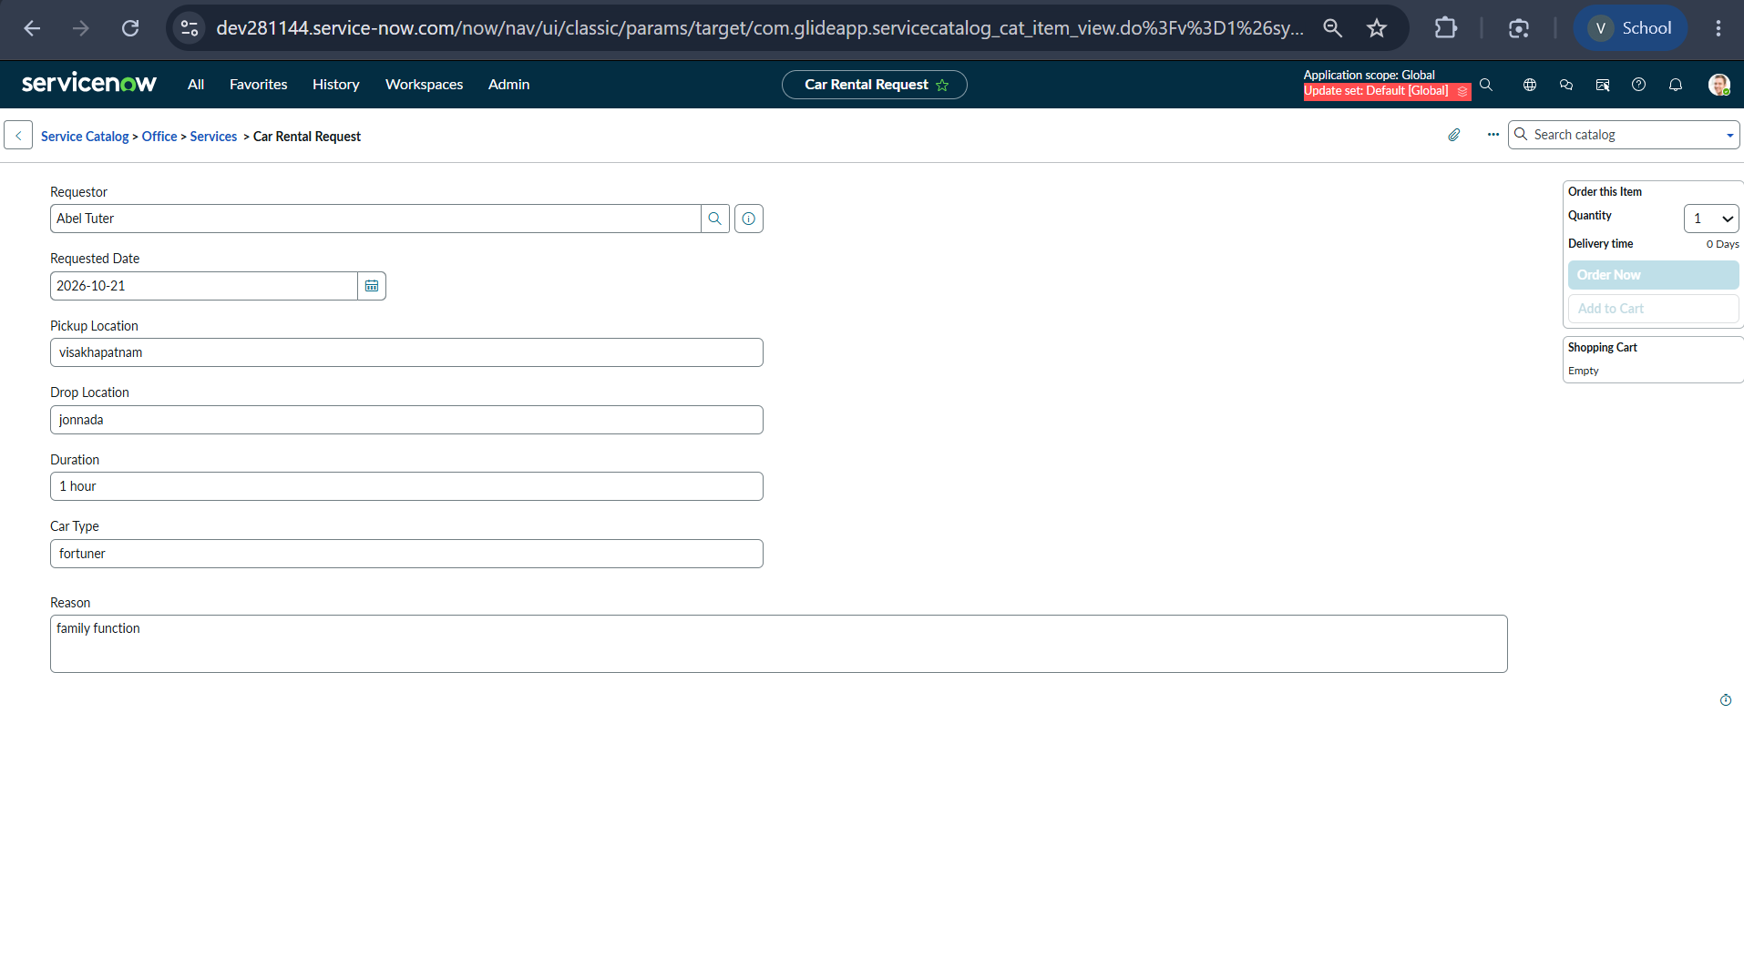
Figure 2. Car Rental Request catalog form (Try It) with the seven request fields filled in.
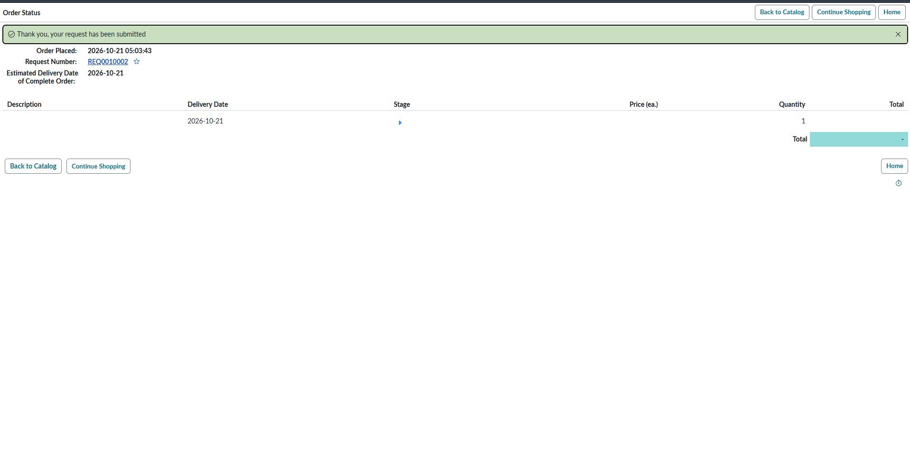
Figure 3. Order Status page confirming that the request has been submitted and showing the request number.
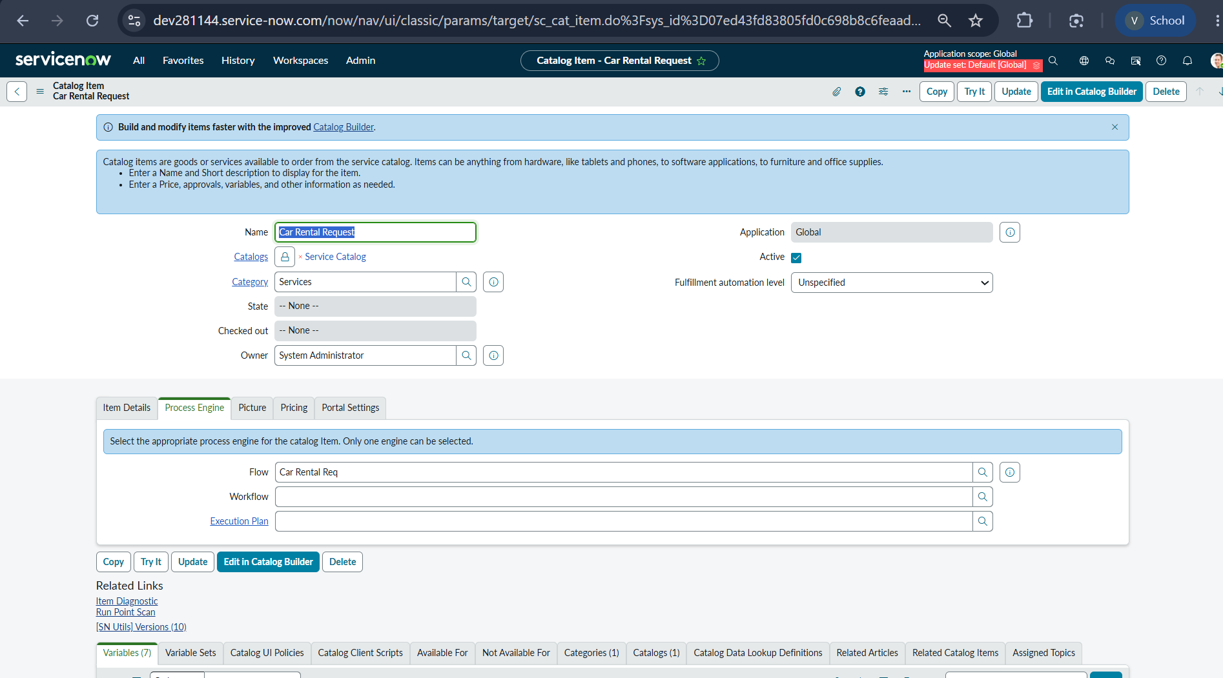
Figure 4. Car Rental Request catalog item configuration; the Process Engine tab shows the Flow field set to Car Rental Req.
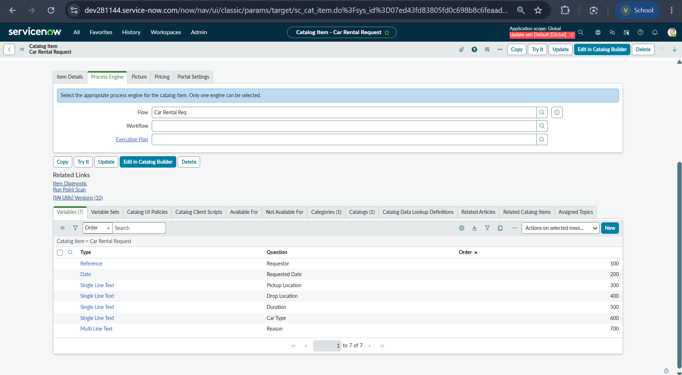
Figure 5. Catalog item variable list showing the seven variables and their order.
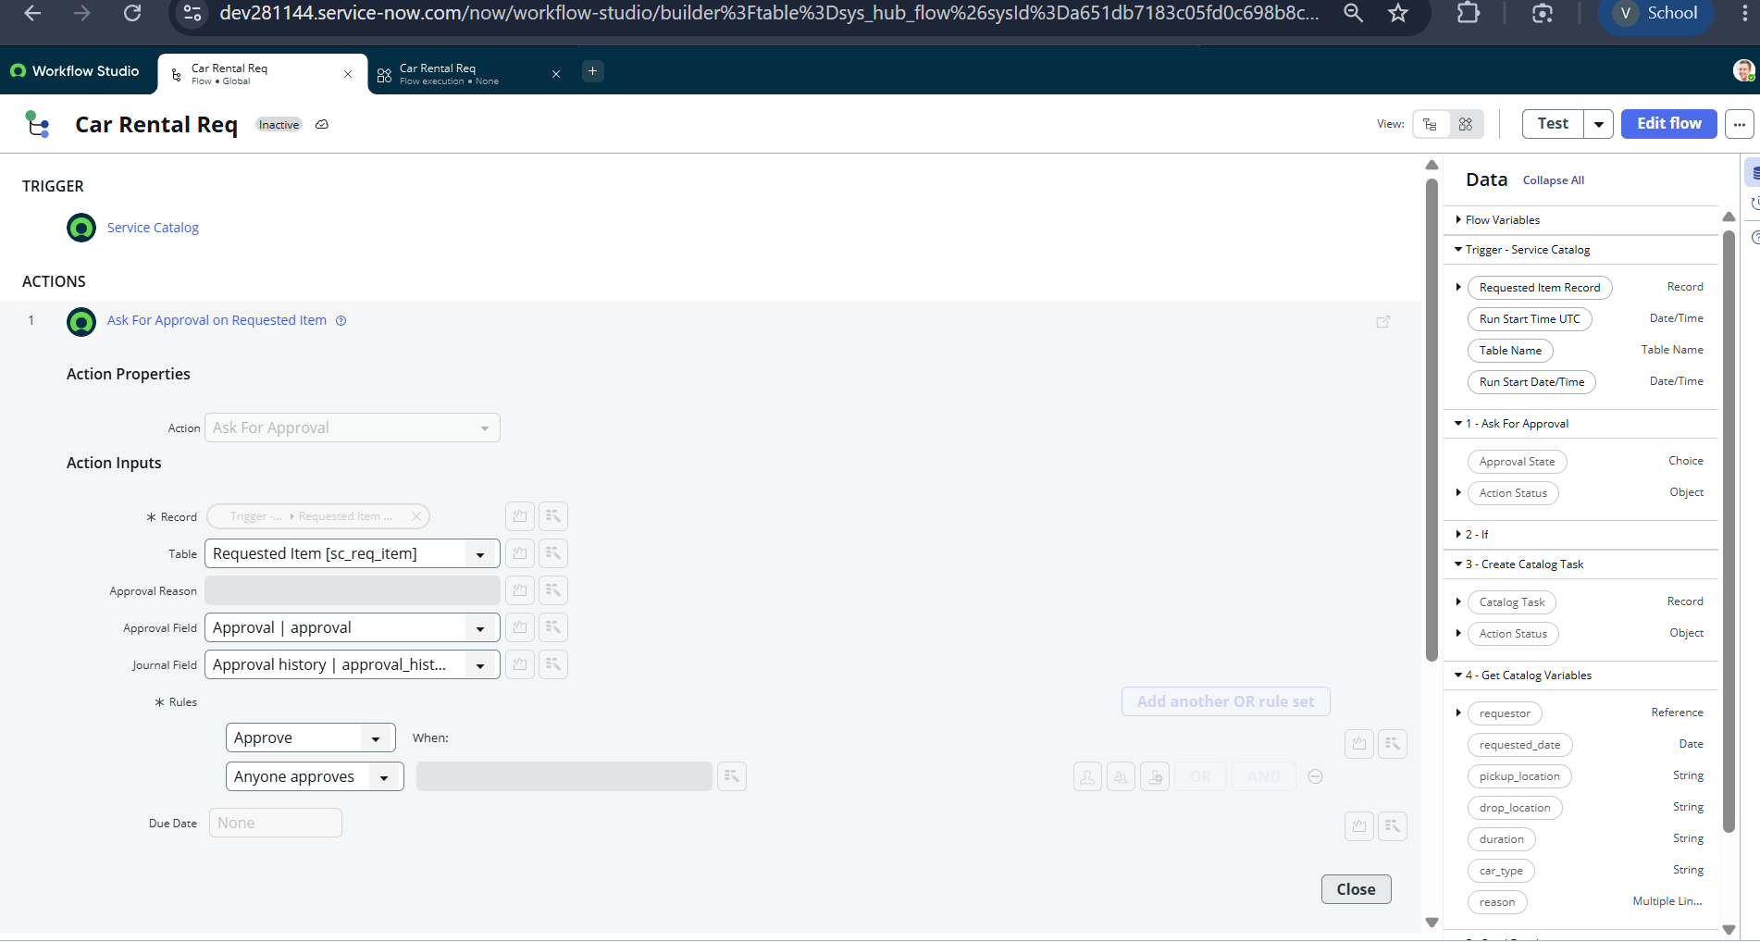
Figure 6. Car Rental Req flow: Service Catalog trigger and the Ask For Approval on Requested Item action with the Approve rule.
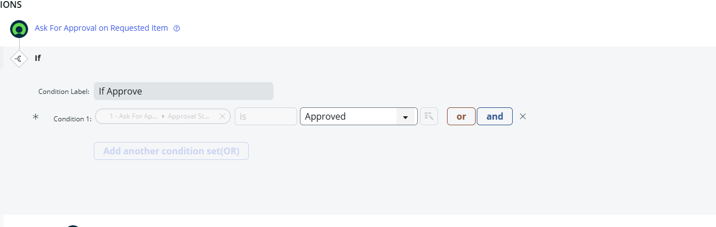
Figure 7. If condition (If Approve) checking that the approval state is Approved.
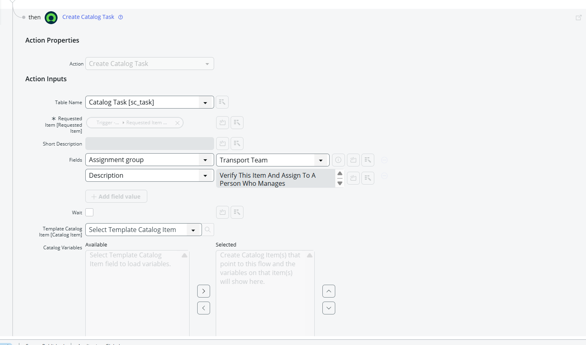
Figure 8. Create Catalog Task action creating an sc_task with assignment group Transport Team.
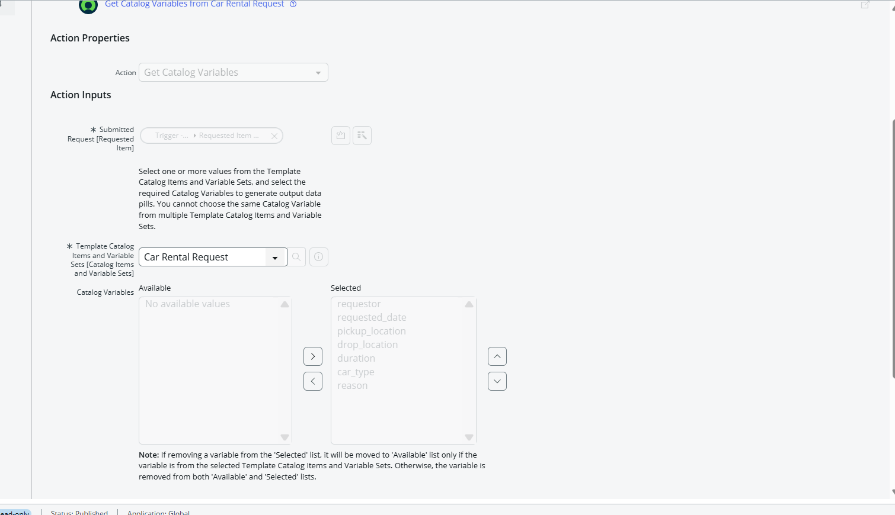
Figure 9. Get Catalog Variables action retrieving the seven variables from the Car Rental Request item.
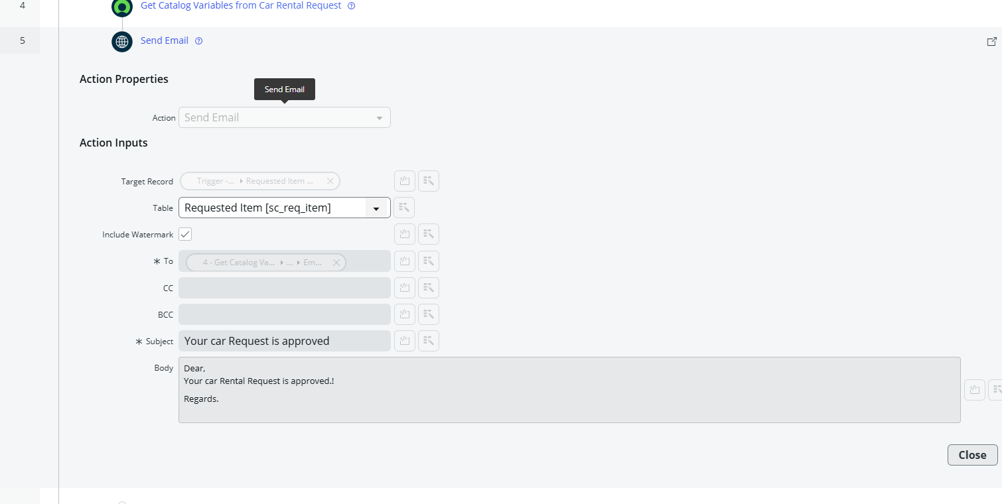
Figure 10. Send Email action with the subject “Your car Request is approved” and the message body.
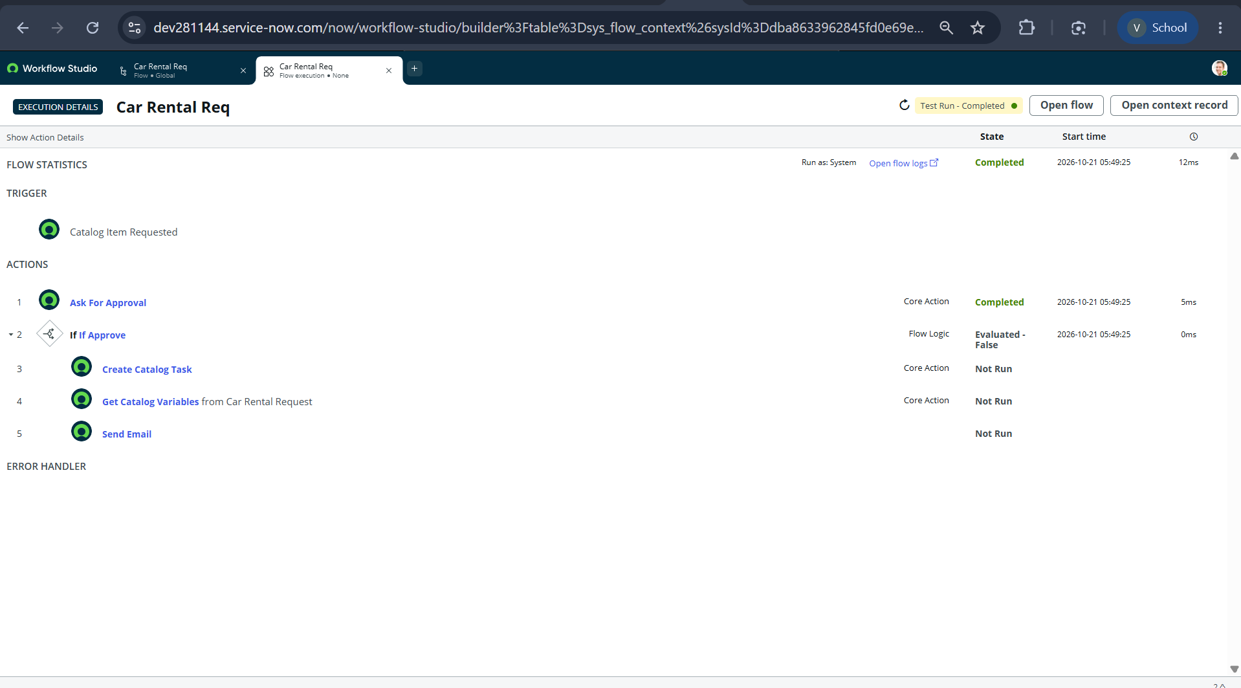
Figure 11. Flow execution details for a test run before approval: the If condition is evaluated as False and the branch actions are Not Run.
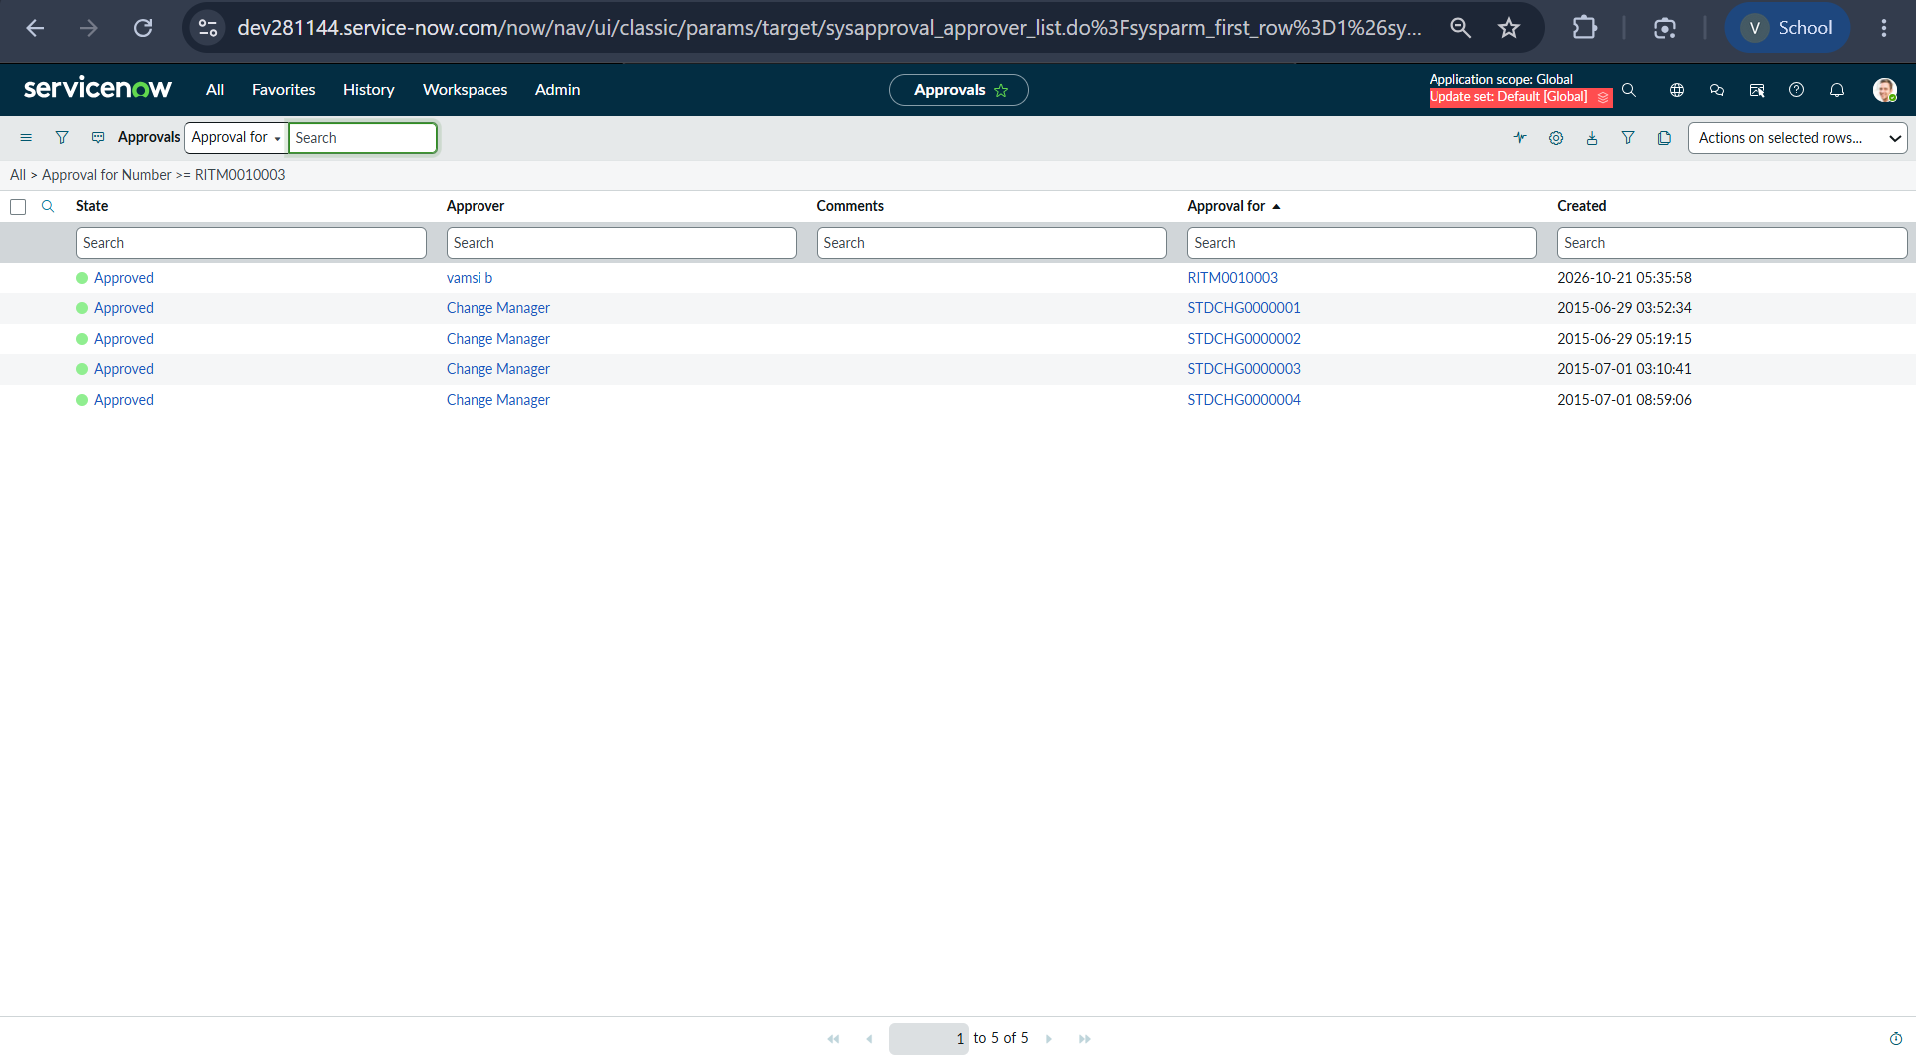
Figure 12. Approval record in the Approved state for the requested item.
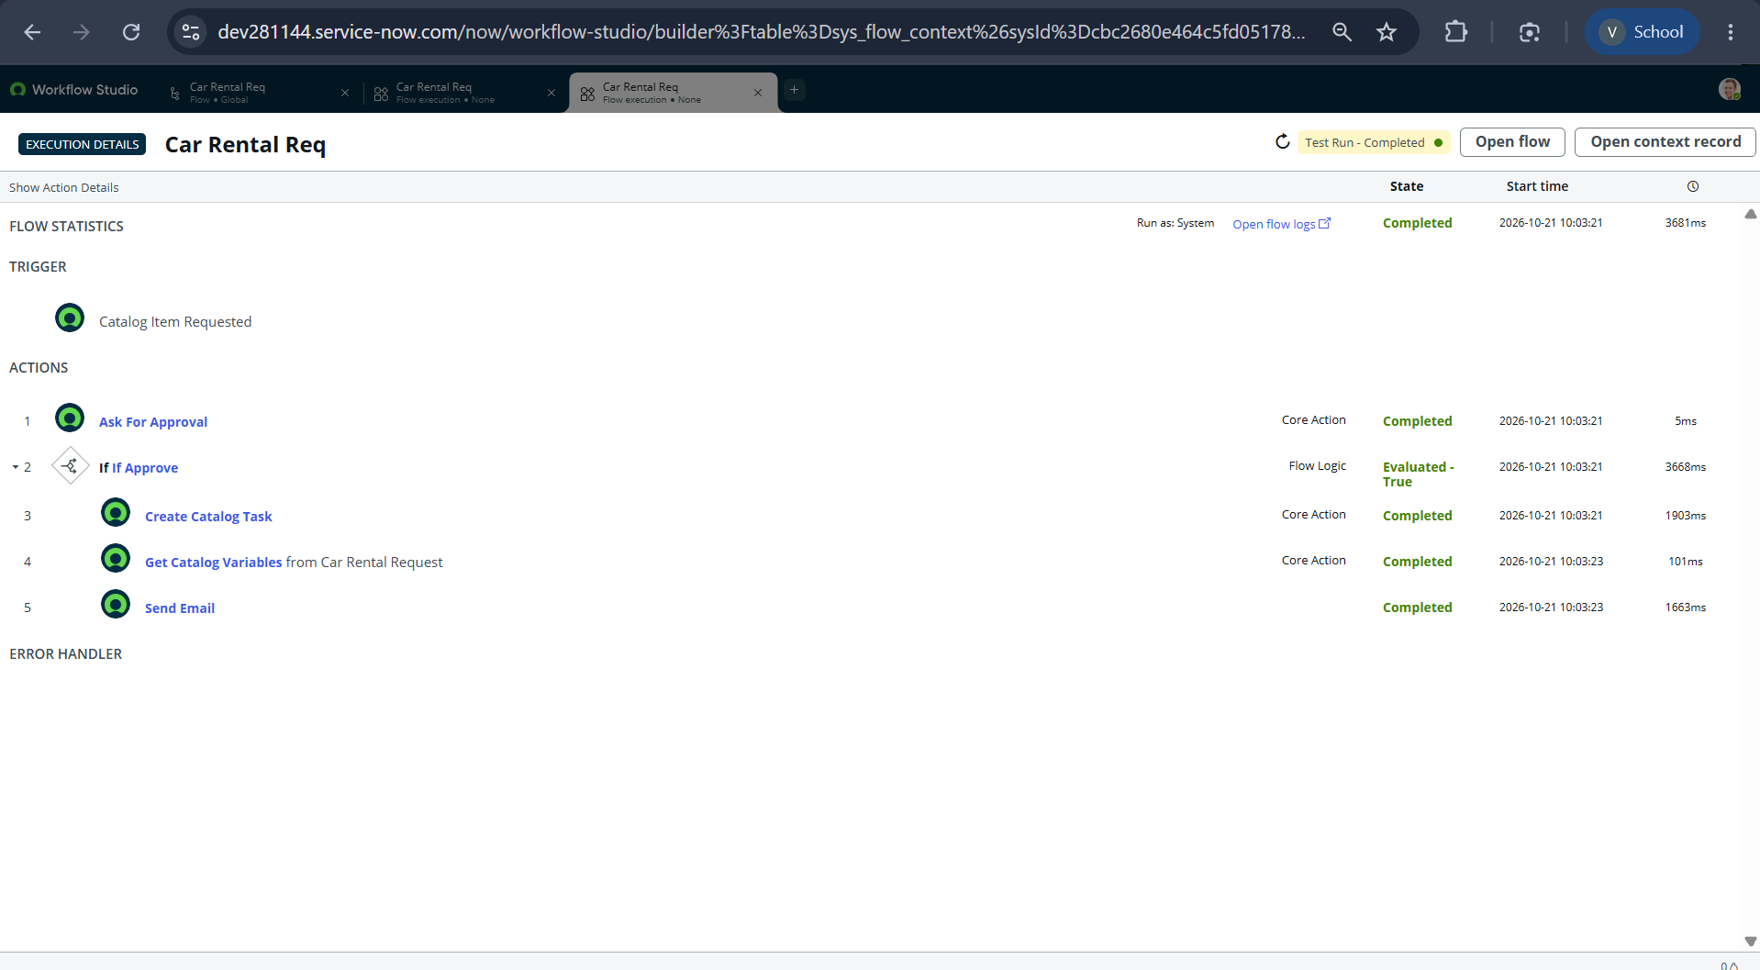
Figure 13. Flow execution details after approval: the If condition is evaluated as True and all five actions are Completed.
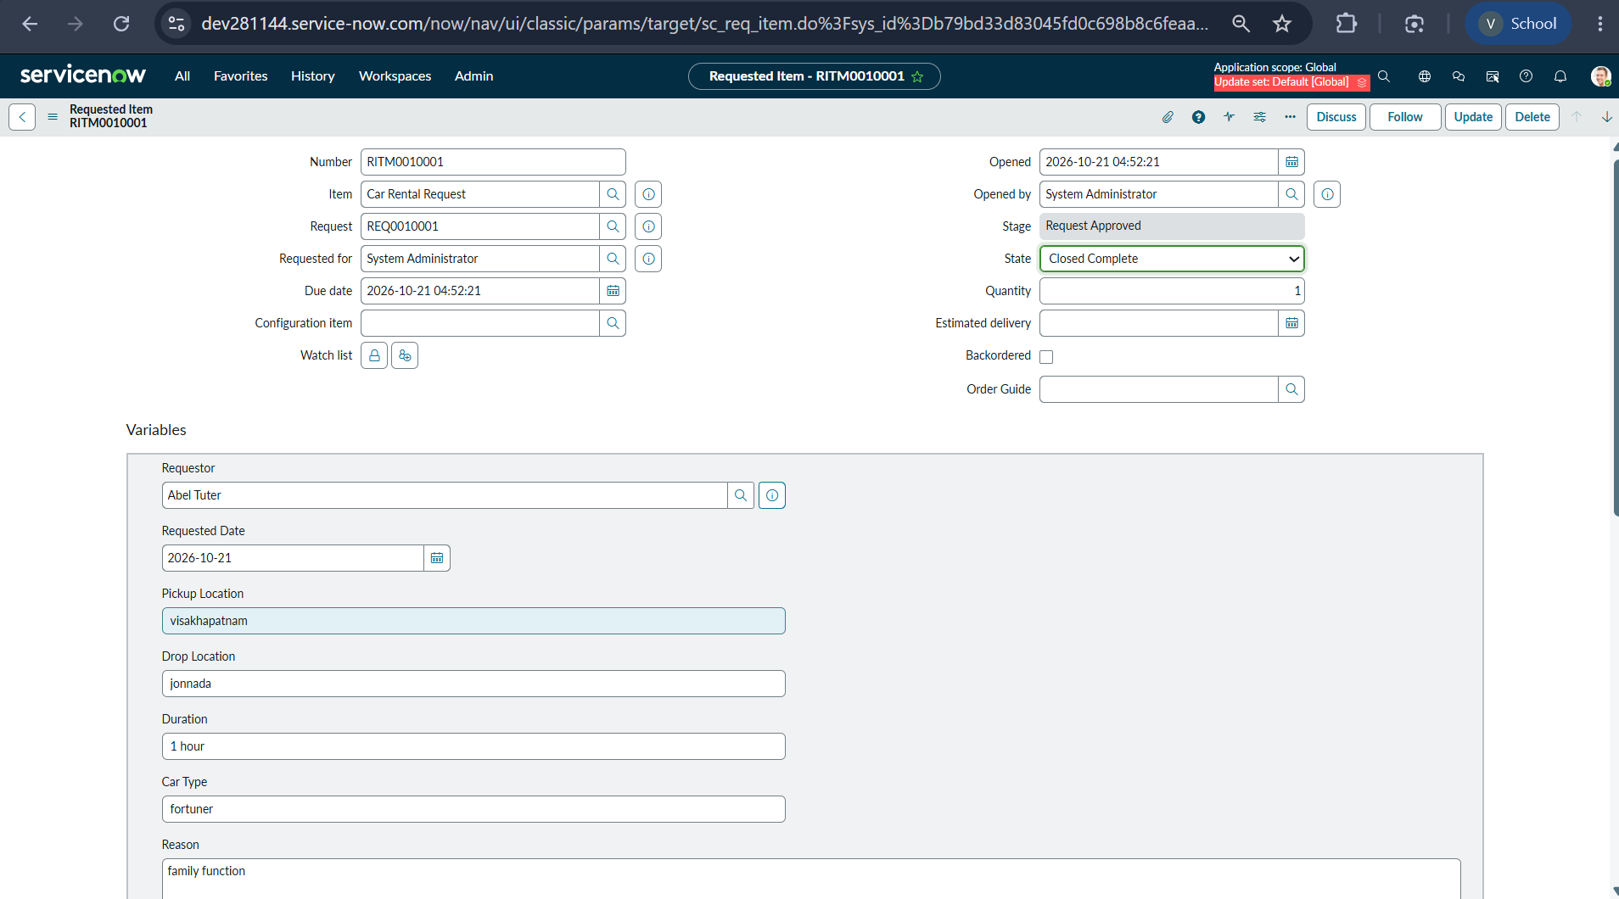
Figure 14. Requested Item RITM0010001 showing the item, stage “Request Approved”, state “Closed Complete” and the stored variable values.
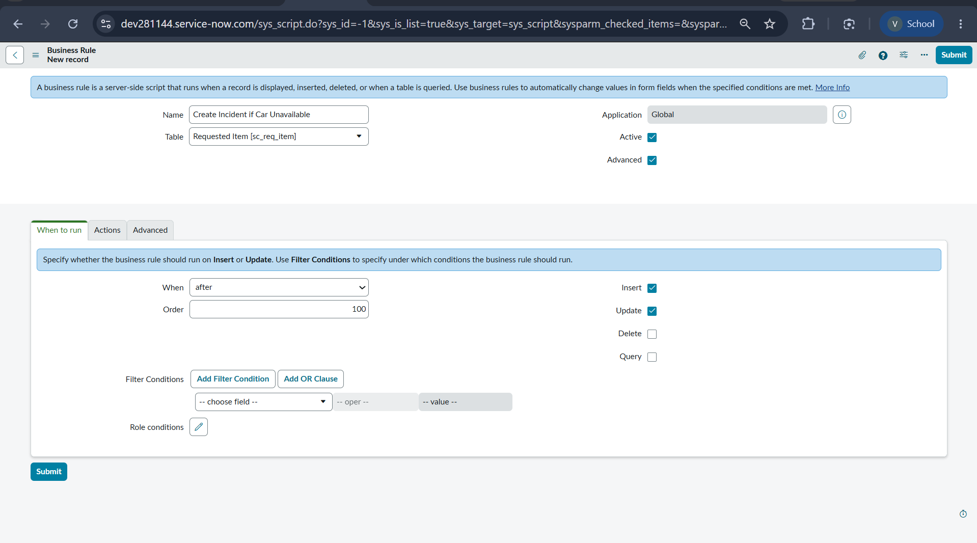
Figure 15. Business Rule “Create Incident if Car Unavailable” on Requested Item [sc_req_item], When to run tab (after, order 100, insert and update).
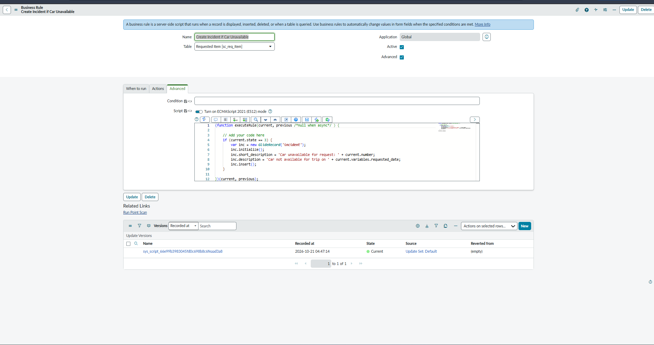
Figure 16. Saved Business Rule showing the Advanced script and its current update version in the Default update set.
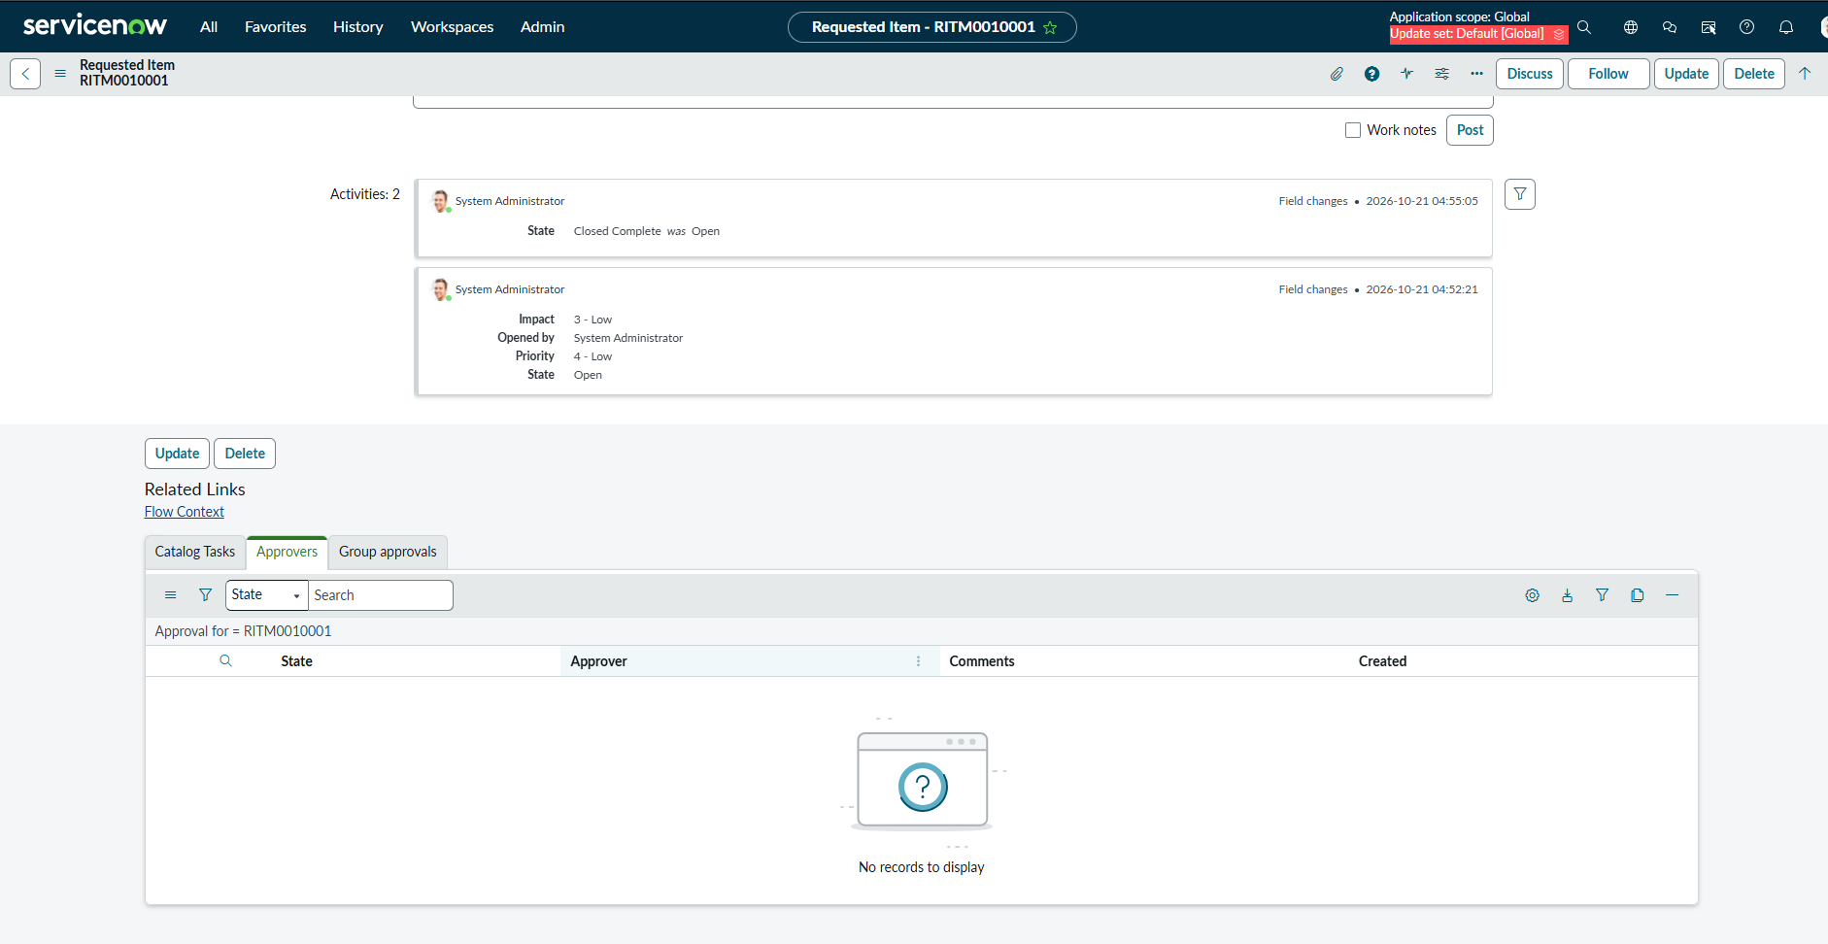
Figure 17. Requested item activity log showing the State change to Closed Complete that triggered the Business Rule.
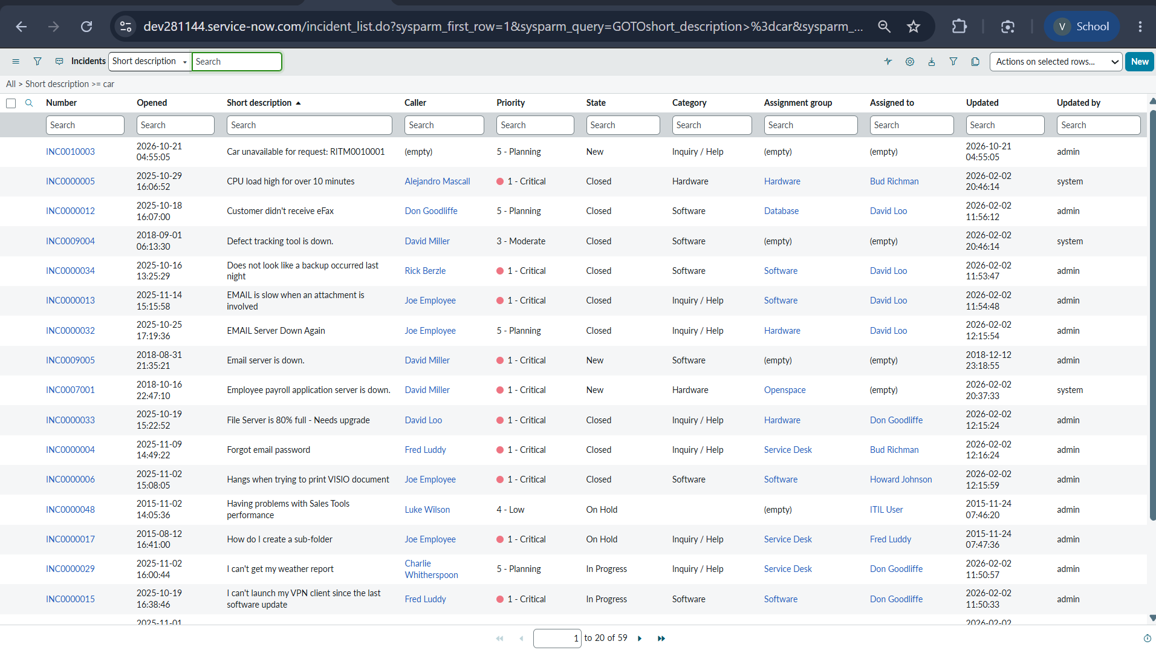
Figure 18. Incident INC0010003 “Car unavailable for request: RITM0010001” created automatically by the Business Rule.
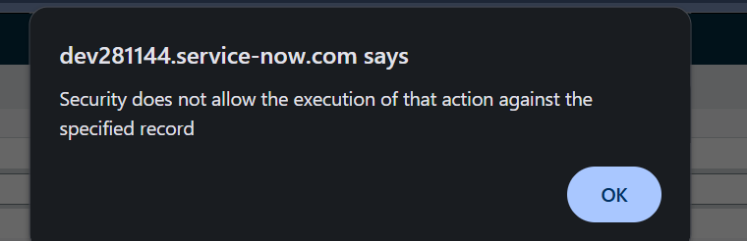
Figure 19. Security message observed during testing, used in the troubleshooting guidance.

11. Benefits and Client Value

11.1 Operational benefits
- Standardized intake: the catalog form guides requesters to provide pickup, drop, duration, car type and reason in a consistent structure.
- Reduced manual coordination: Flow Designer connects approval, task creation, variable retrieval and email in one process.
- Improved traceability: request records, approvals, catalog tasks and incidents provide related evidence of the request lifecycle.
- Clear ownership: the Transport Team is assigned automatically after approval.
- Faster communication: the requester receives an approval email without manual follow-up.
- Exception tracking: unavailable cars are recorded as incidents instead of being lost.
- Easier administration: ServiceNow-native configuration and an Update Set make the solution simple to maintain and move.

11.2 How a client could use it
An organization’s admin, travel or transport desk could adapt this pattern for employee car rental, pool vehicle booking or other transport requests. The client would tailor the request fields, approval rules, assignment groups, notifications and incident categories to its own travel policy.
The value is not that ServiceNow books the physical vehicle by itself. The project automates the request-management workflow around the booking. Actual vehicle reservation with a fleet vendor would require a connected fulfillment procedure or integration if that capability is needed.

12. Limitations and Known Considerations
- The Business Rule uses state 3, which is Closed Complete in the standard instance. Closed Complete is also the normal outcome for a successfully fulfilled request, so a successful booking would also create an incident. A production version should use a different condition, such as Closed Incomplete or a dedicated variable or field that marks the car as unavailable.
- The Duration, Pickup Location, Drop Location and Car Type variables are free-text fields. Production use should replace them with choice or reference fields and validation, for example a list of cars and locations.
- In the flow, the catalog task, variable retrieval and email actions run only inside the approved branch. There is no rejected-branch action shown, so a rejected requester receives no email from the flow.
- The approver is a single user (Ajay H or System Administrator). Department-based, manager-based or car-type-based approval routing was not shown and is not claimed.
- Two catalog items named Car Rental Request exist in the catalog item list (categories Services and Facilities). Make sure that the intended item is linked to the Car Rental Req flow and the duplicate is deactivated or removed.
- Car availability is not checked automatically against an inventory; availability is handled by the Transport Team after approval.
- Test email addresses (for example ajay@example.com) should be replaced by real addresses in a production instance.

13. Future Enhancements
- Add a Car Inventory table and check car availability automatically in the flow.
- Add a rejected branch that notifies the requester and records the reason.
- Add a manager approval step based on the requester’s manager and a second approval for high-cost cars.
- Add Catalog UI Policies or client scripts for mandatory fields, date validation and auto-fill.
- Replace the free-text car type and location fields with choice lists or reference fields.
- Add SLA monitoring and a dashboard for request volume, approval time and unavailable-car incidents.
- Add notifications for task assignment, completion and closure.
- Integrate with an external fleet or vendor system for real-time booking.

14. Conclusion
The Car Rental Request Automation project demonstrates how ServiceNow can streamline the car rental process through a standard catalog form, an automated approval flow, automatic task assignment to the Transport Team, an approval email and a Business Rule that tracks unavailable cars as incidents. The solution improves efficiency, transparency and accuracy while reducing manual effort and processing time. The documented design is configured entirely on the ServiceNow platform and can be extended with inventory checks, rejection handling and reporting.

